Semantic Person Search

Name

# Description of the algorithm

1. We eliminated the bad data and normalized the data. In the color classification problem, we also performed data enhancement operations such as image flipping.
2. We use ResNet34 as our method and add a classifier to the last layer to get the results we want. The reason for using this network is that it has been proven to be very effective in many scenarios on image classification problems. In order to speed up the training speed, here we use pytorch’s pre-trained initialization parameters when training the network, the loss function uses the crossentropy loss function, the optimization algorithm uses the Adam algorithm, and the learning rate is set to automatically decrease.
3. Our algorithm basically achieves an accuracy of 80%−90% on these test sets within 50 to 100 iteration steps. Due to the small amount of data, this effect is still very successful. If you want better results, you need more data. Regarding semantic search, we can use CNN to first extract the features we want from the sentence, and then use our image classification algorithm for matching search.
4. Data has been resize to 256,128 sizes and random horizontal flip for increasing the data augmentation.

# Results

In this section, we list the results of classifying different traits on the testing data set. The number in the upper right corner of each picture represents the recognition result of our algorithm for each picture.

## Gender

There are totally 20 Epoch has been used in training. The best train accuracy is 0.998066 and best valid accuracy is 0.664894. Training was completed in 8 mins.

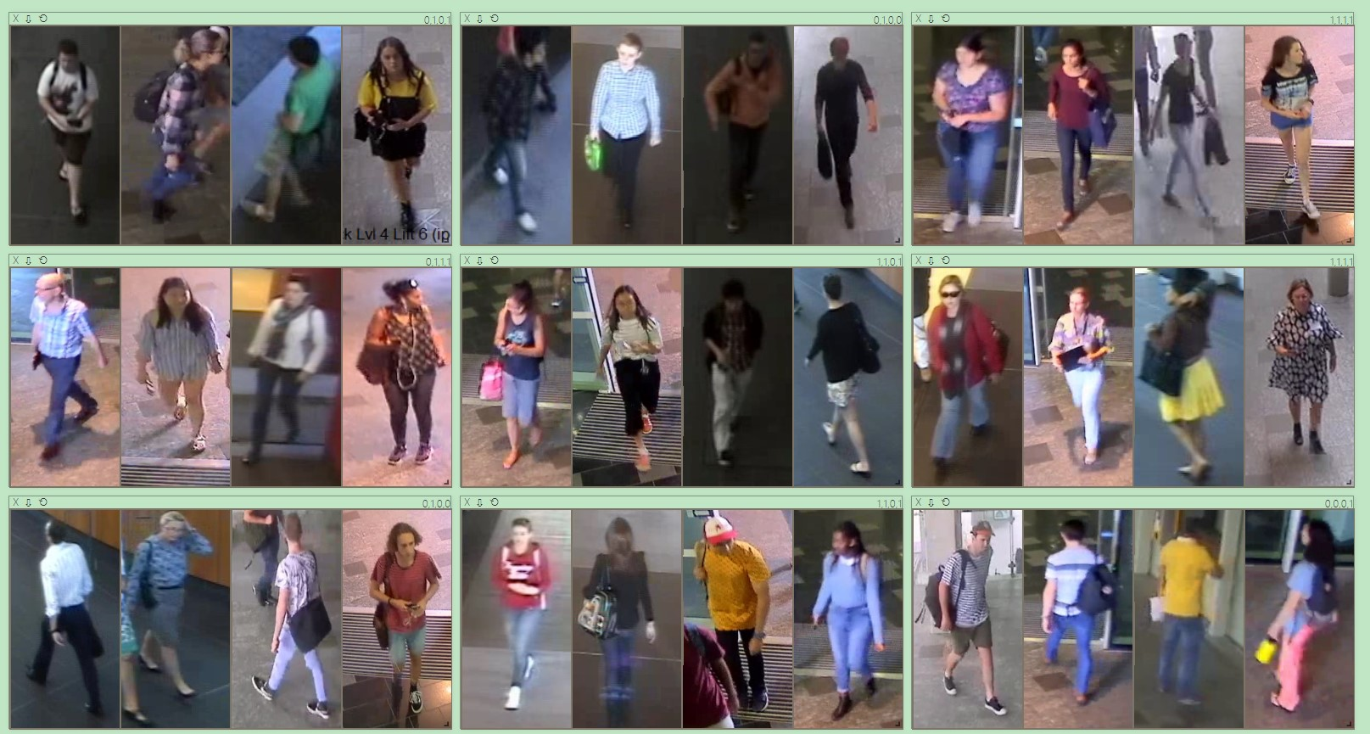

Figure 1: Results of gender classification.

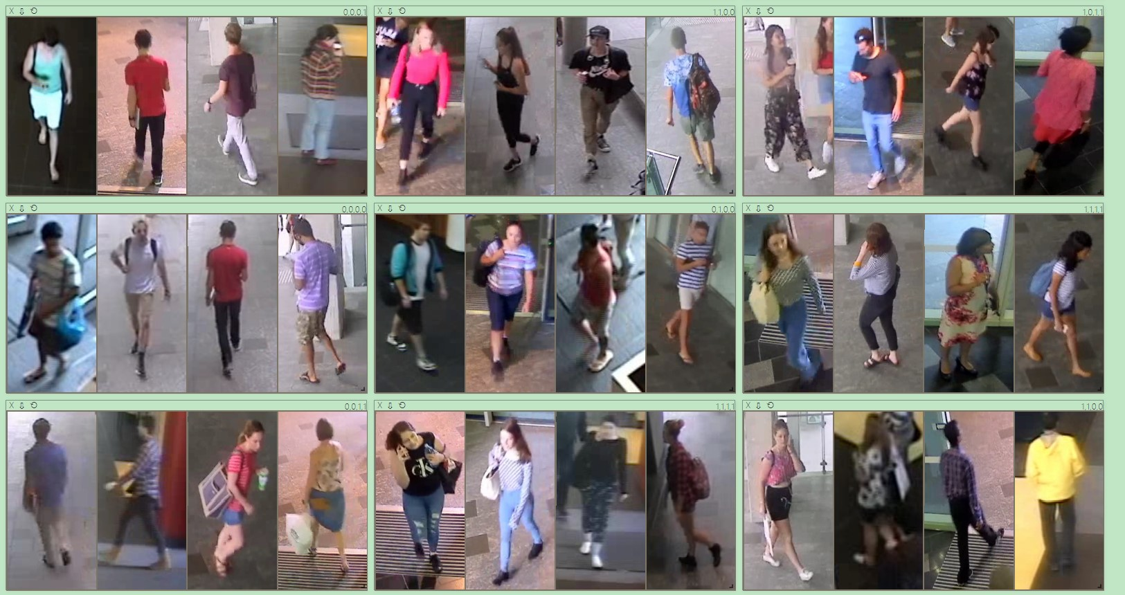

Figure 2: Results of gender classification.

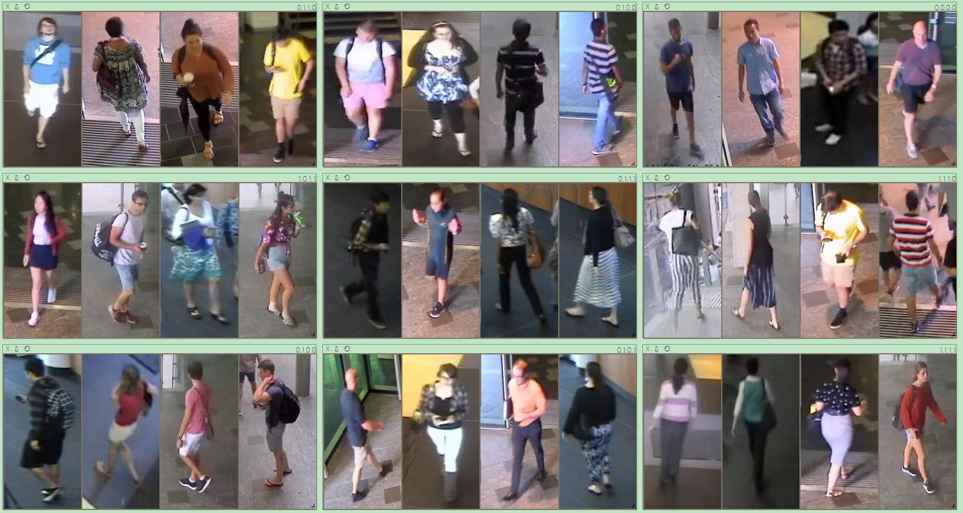

Figure 3: Results of gender classification.

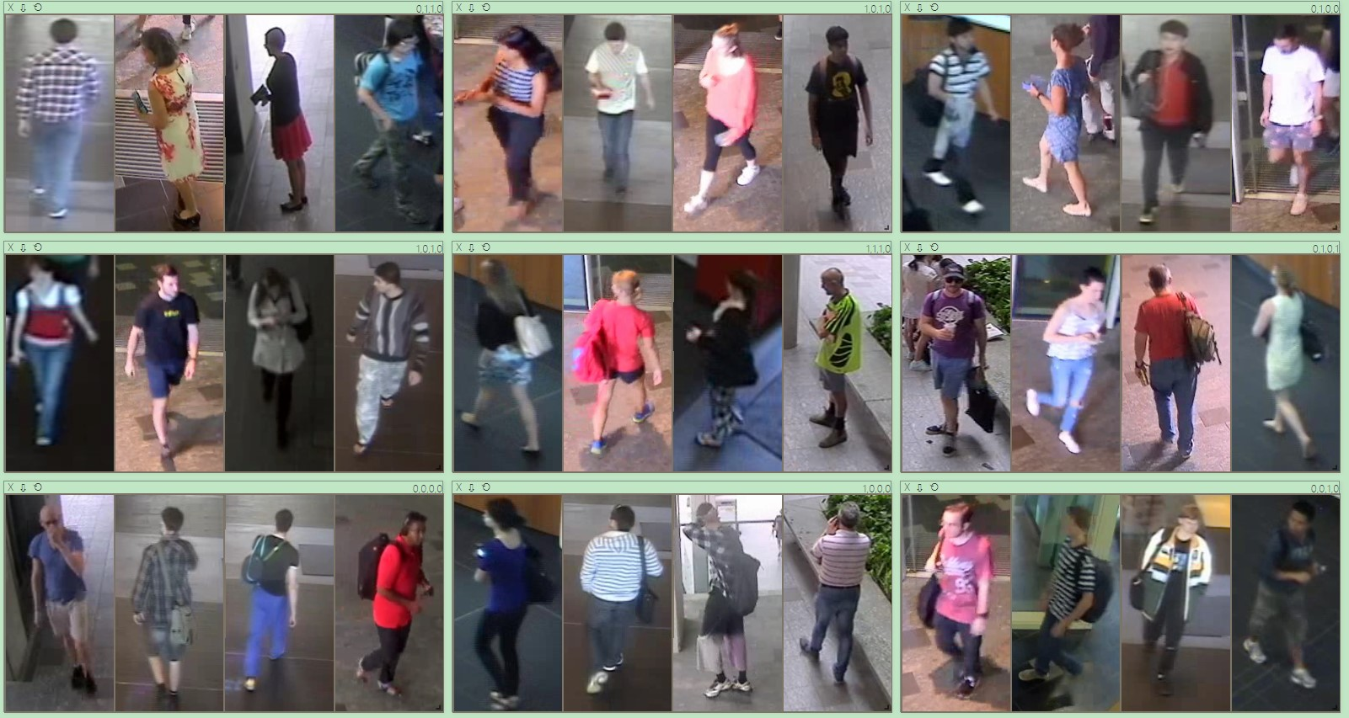

Figure 4: Results of gender classification.

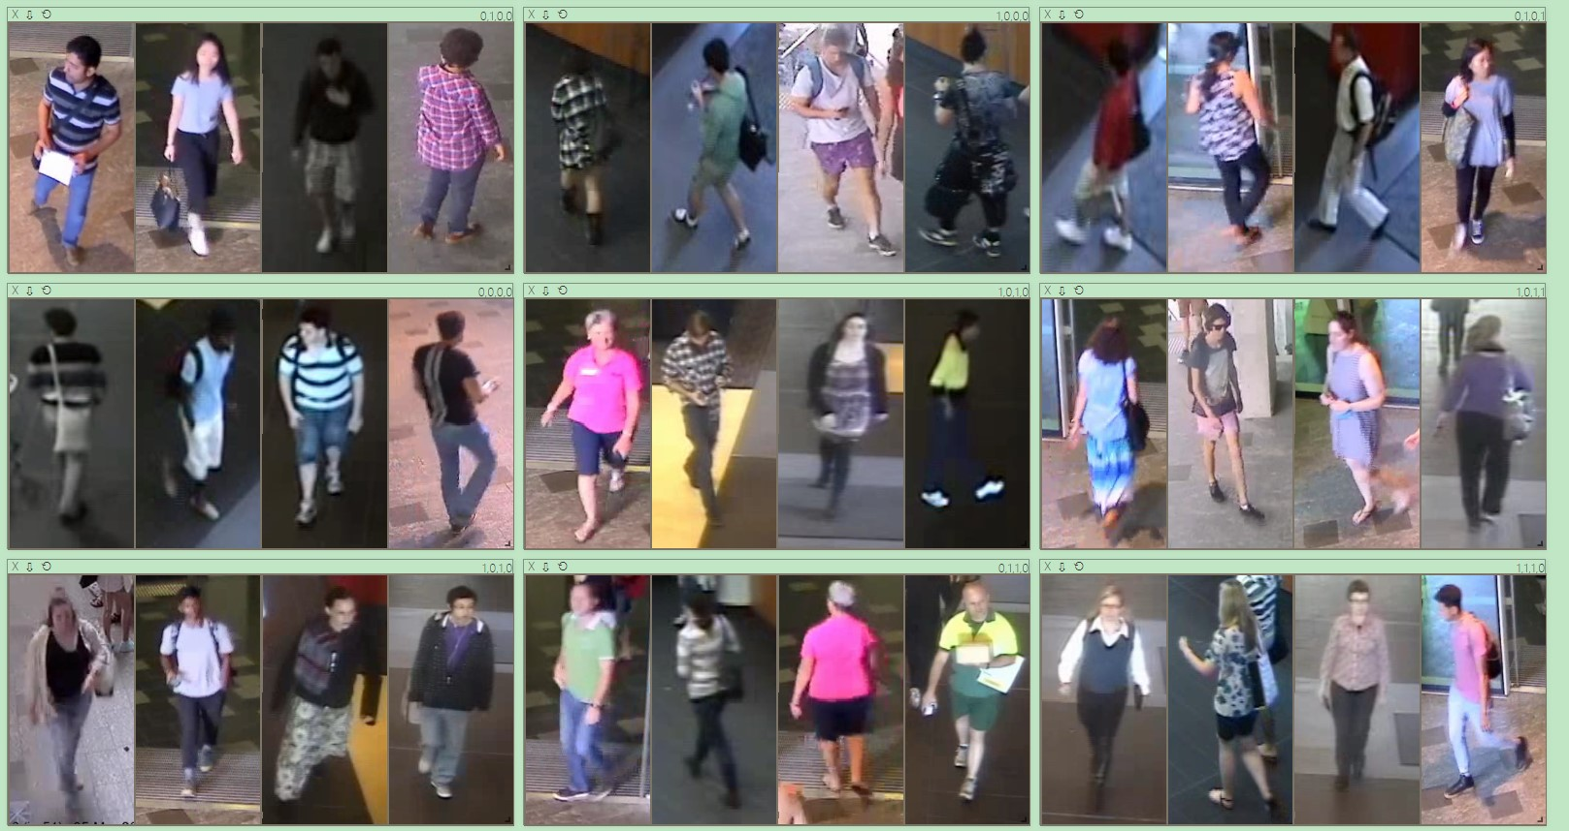

Figure 5: Results of gender classification.

## Torso Clothing Type

There are totally 20 Epoch has been used in training. The best train accuracy is 1.00 and best valid accuracy is 0.544231. Training was completed in 8m 22s.

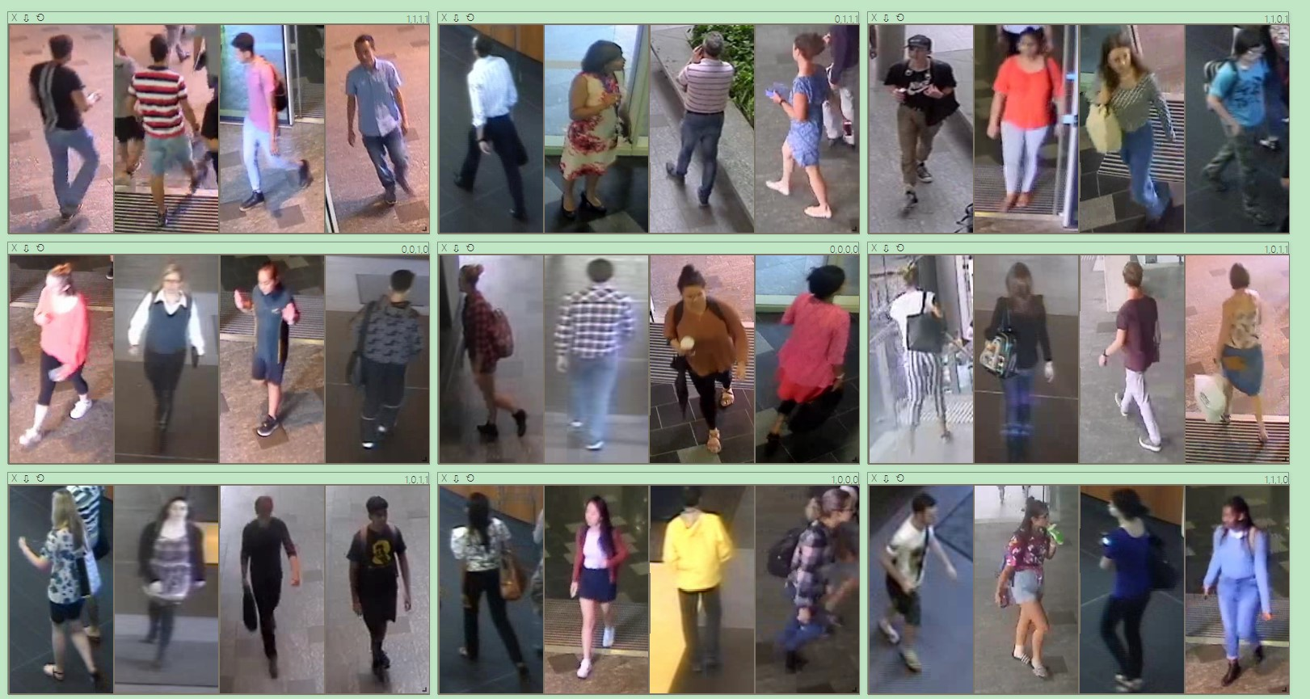

Figure 6: Results of torso clothing type classification.

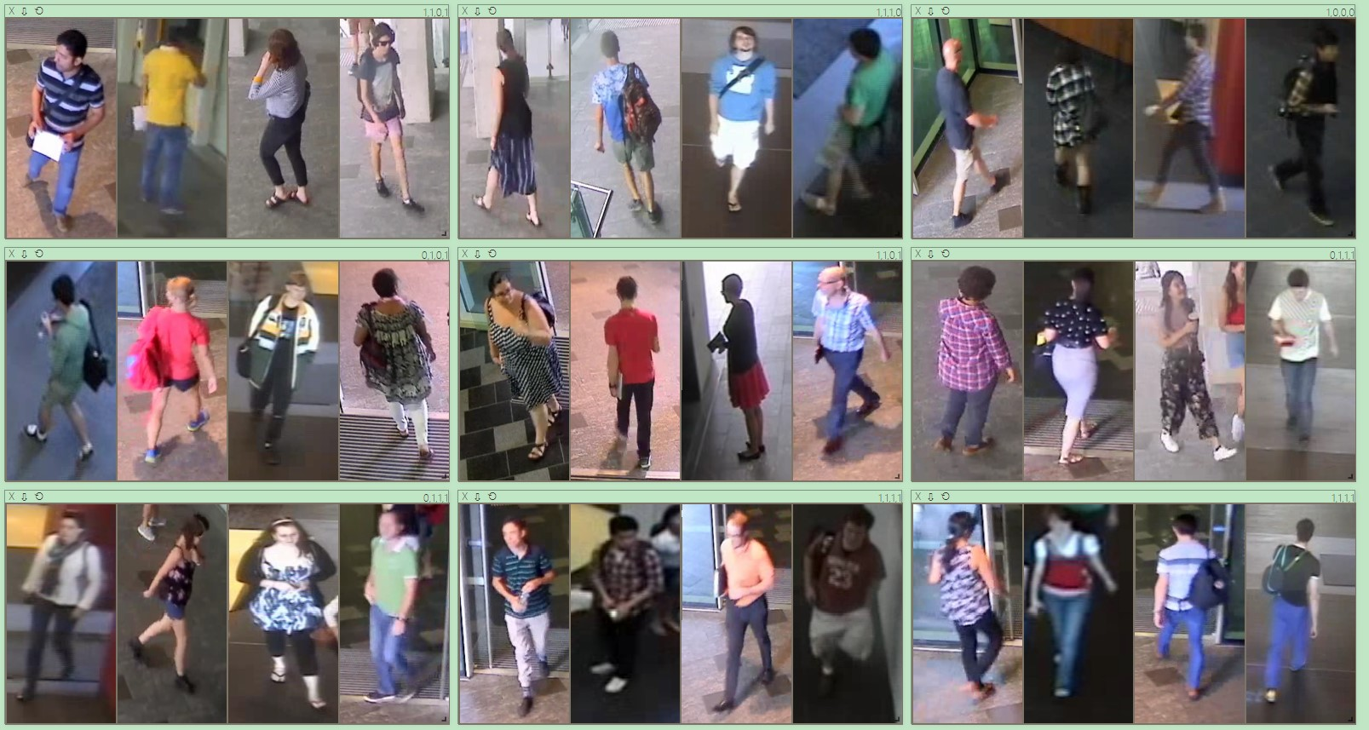

Figure 7: Results of torso clothing type classification.

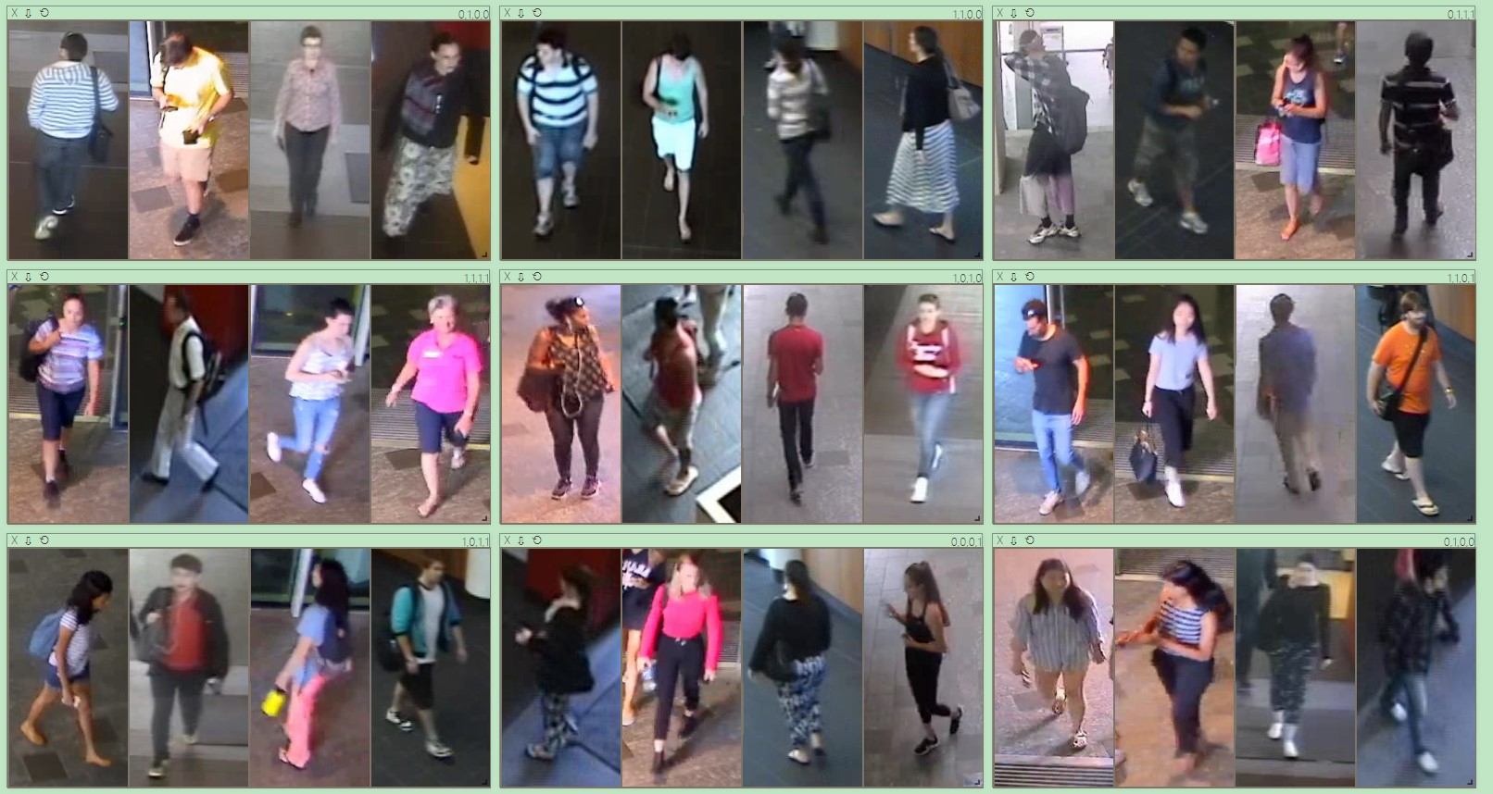

Figure 8: Results of torso clothing type classification.

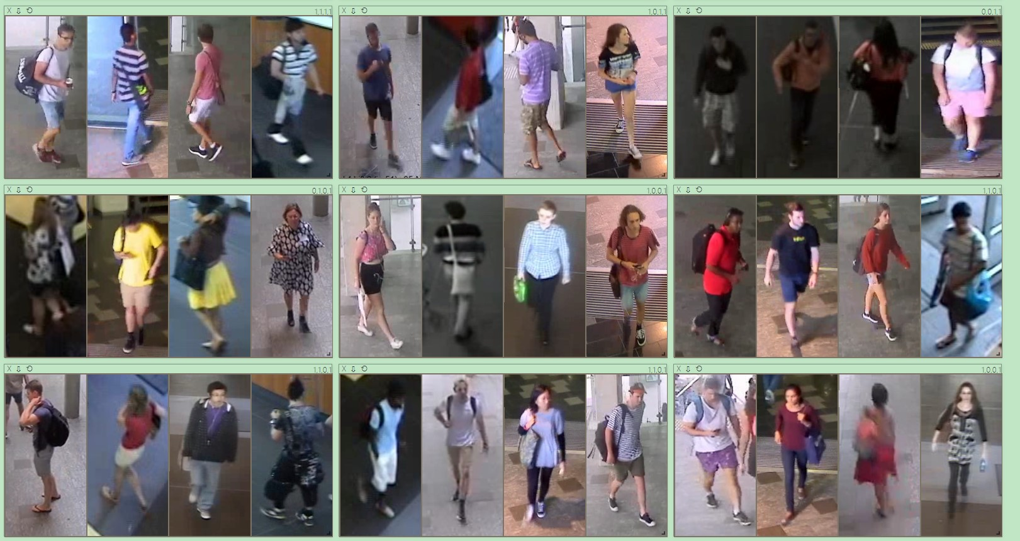

Figure 9: Results of torso clothing type classification.

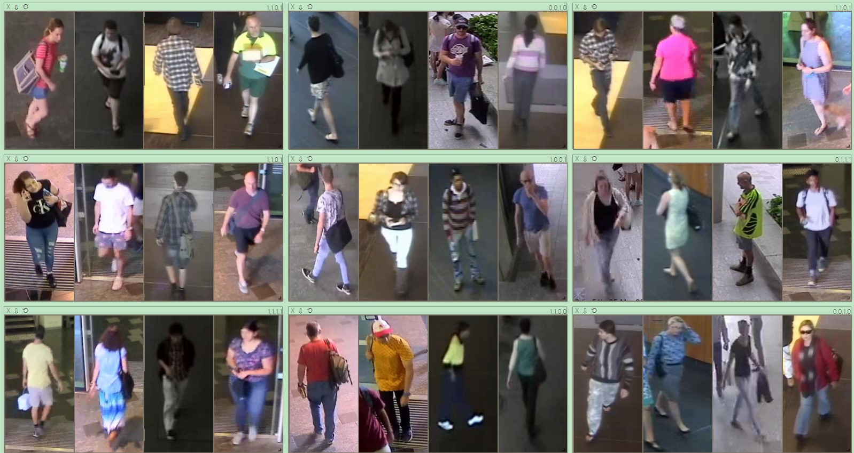

Figure 10: Results of torso clothing type classification.

## Torso Clothing Colour

There are totally 20 Epoch has been used in training. The best train accuracy is 0.829457 and best valid accuracy is 0.474490. Training was completed in 8m 22s.

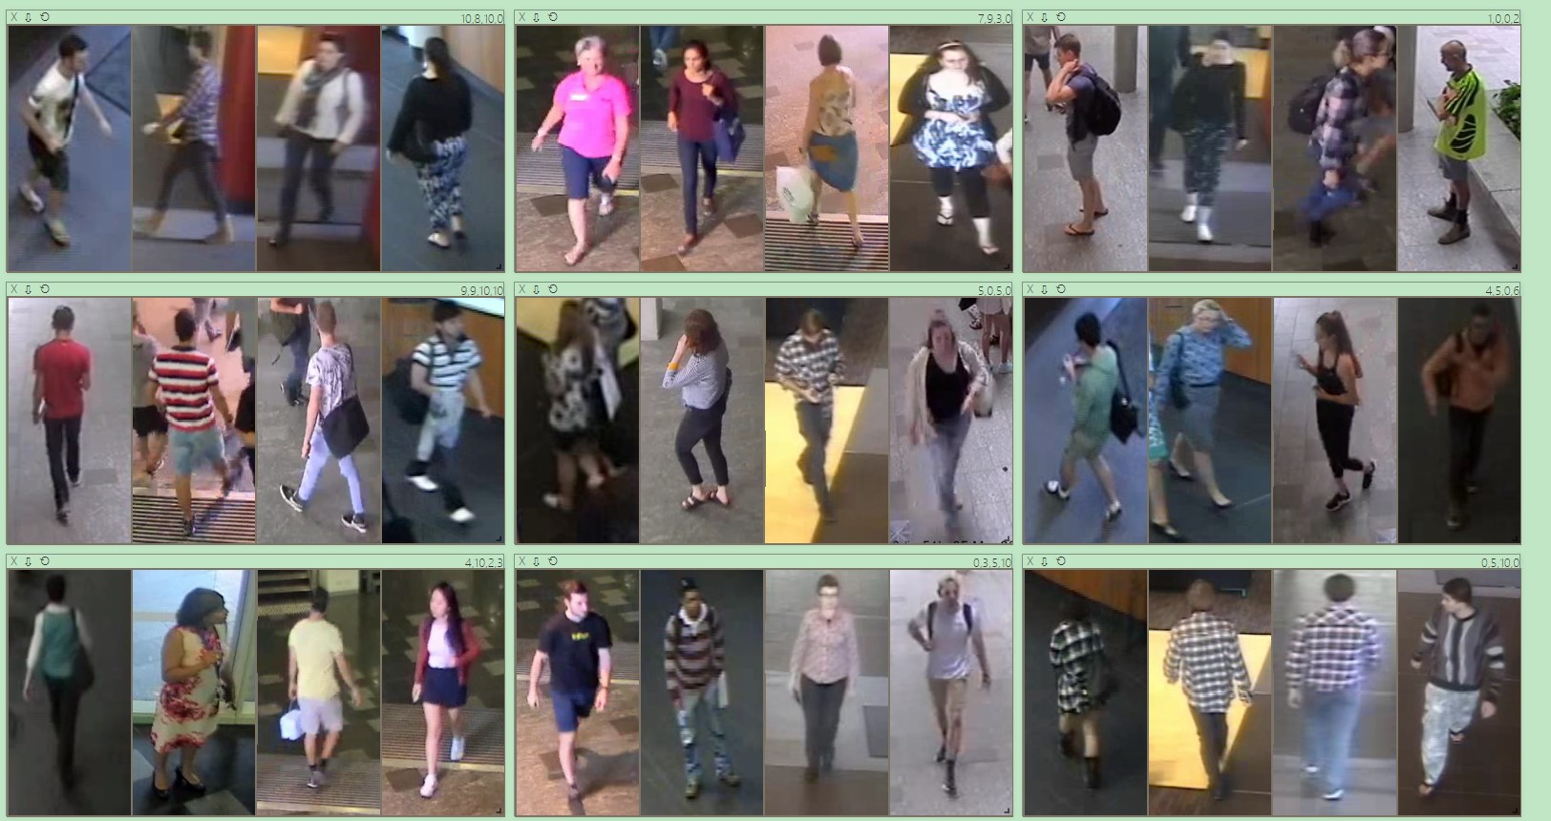

Figure 11: Results of torso clothing colour classification.

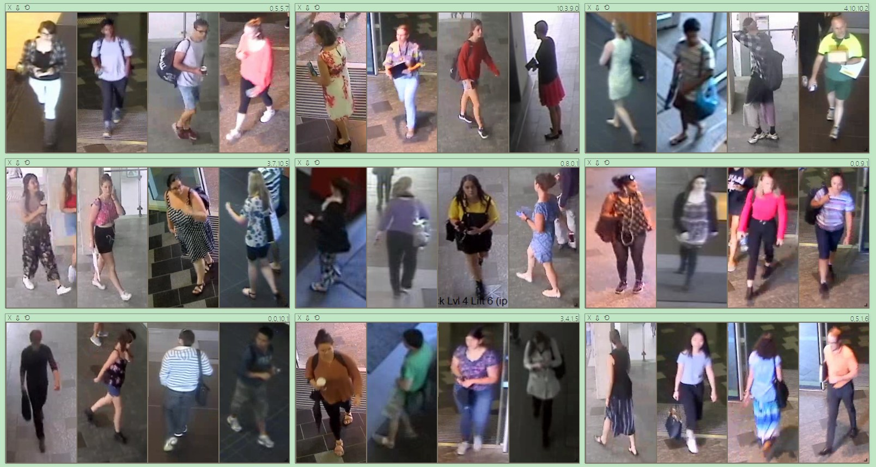

Figure 12: Results of torso clothing colour classification.

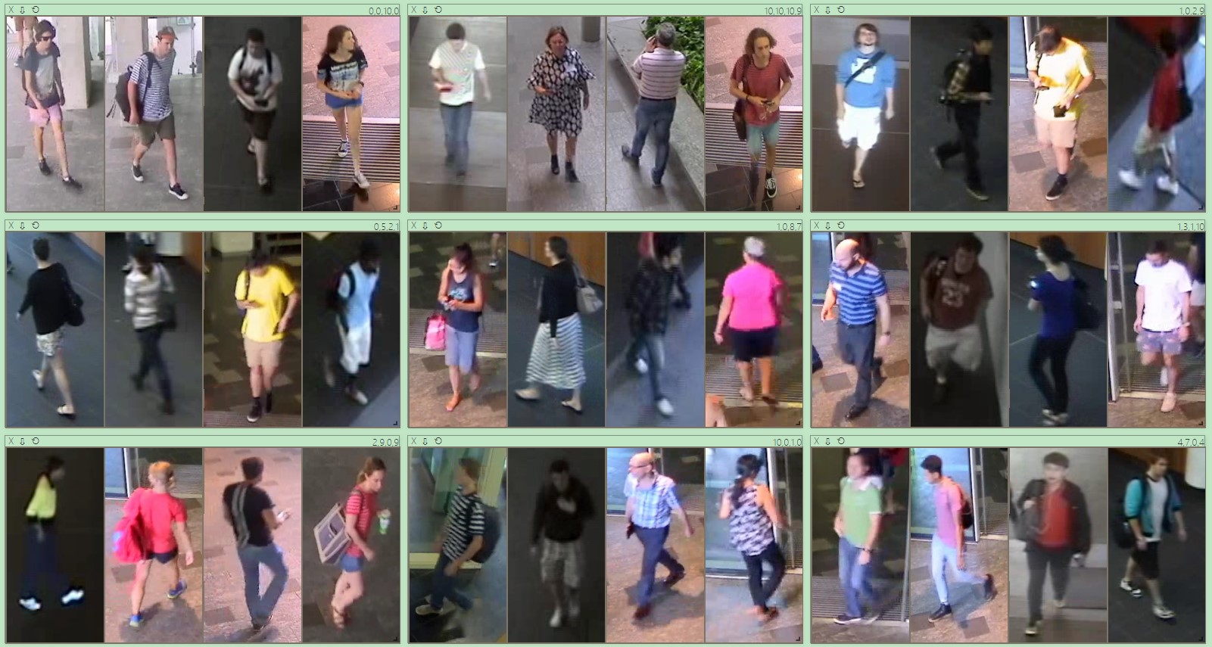

Figure 13: Results of torso clothing colour classification.

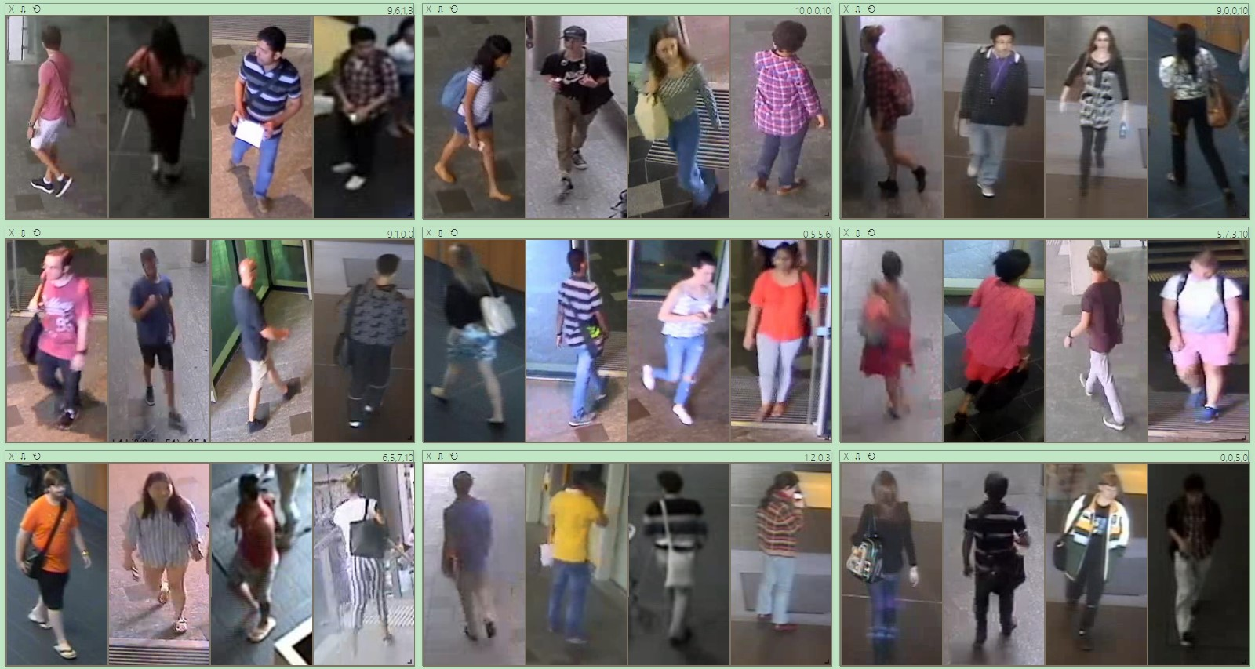

Figure 14: Results of torso clothing colour classification.

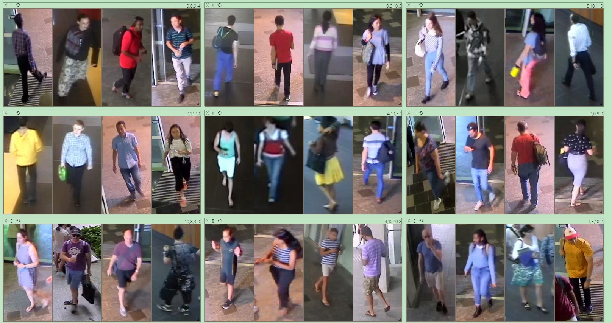

Figure 15: Results of torso clothing colour classification.

## Leg Clothing Type

There are totally 20 Epoch has been used in training. The best train accuracy is 1.00 and best valid accuracy is 0.84. Training was completed in 15m 36s.

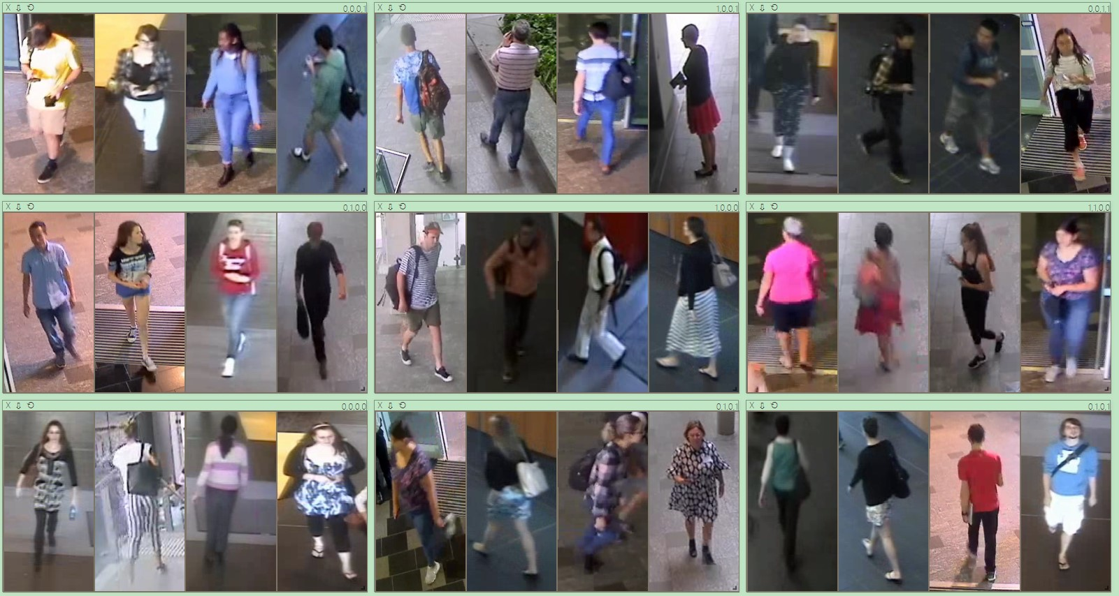

Figure 16: Results of leg clothing type classification.

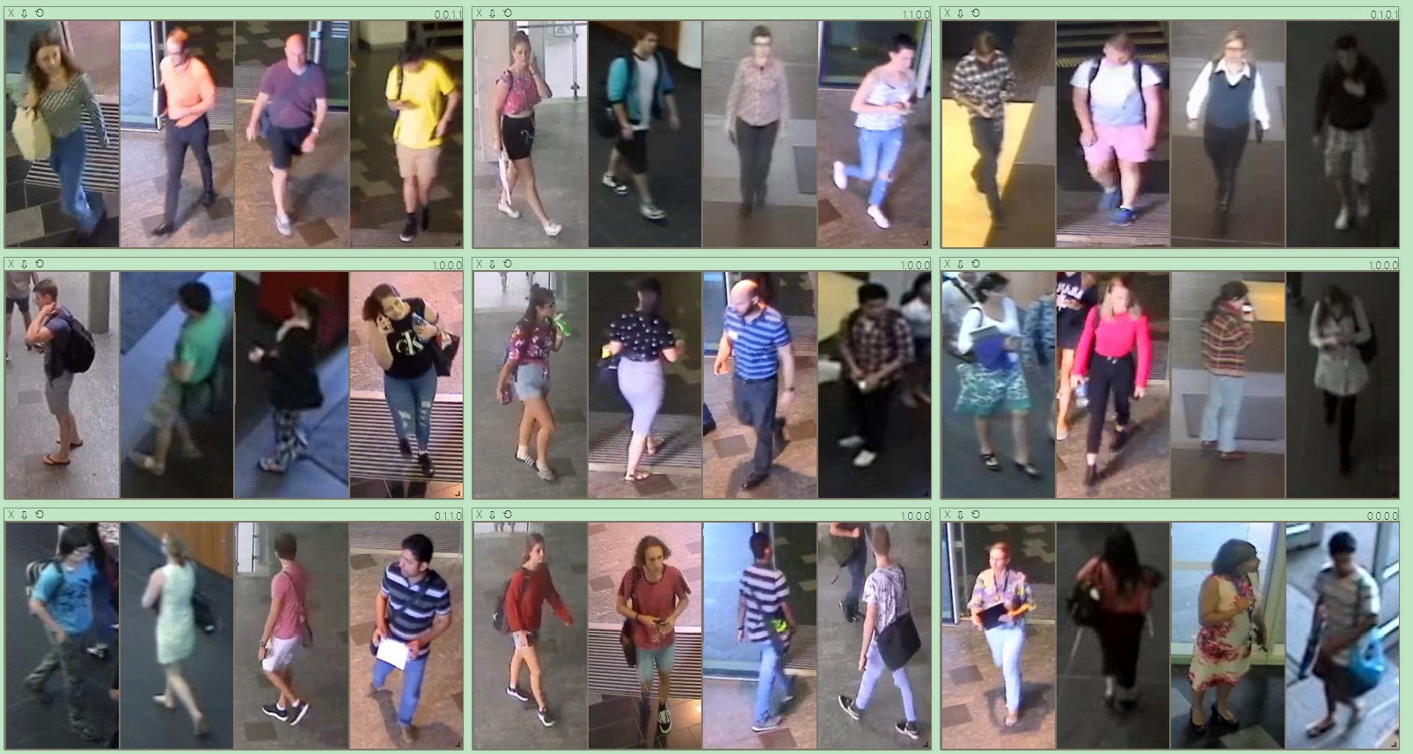

Figure 17: Results of leg clothing type classification.

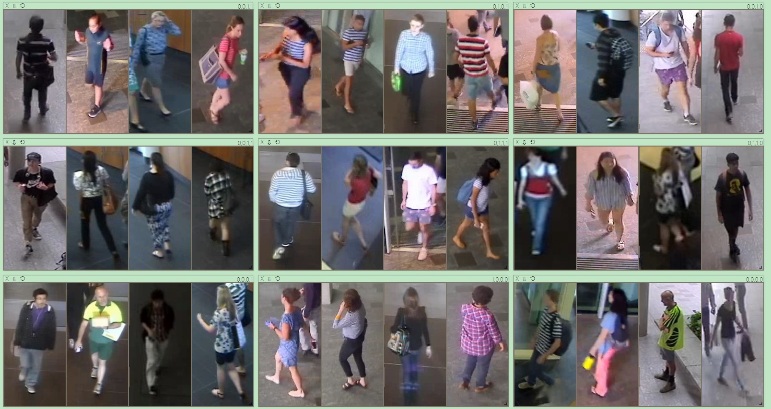

Figure 18: Results of leg clothing type classification.

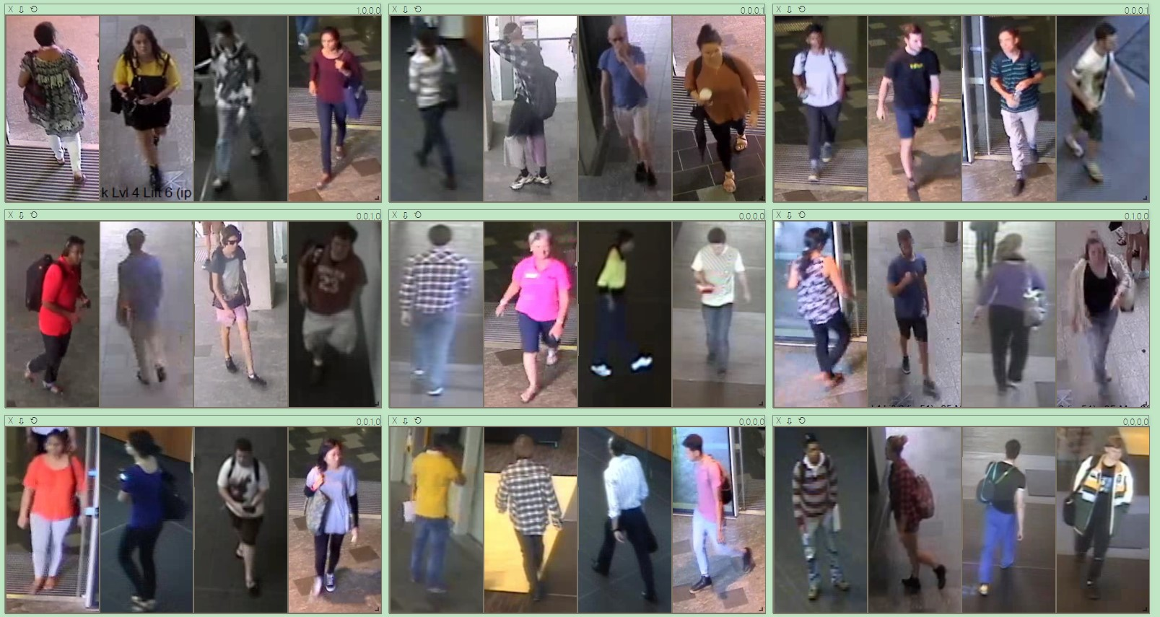

Figure 19: Results of leg clothing type classification.

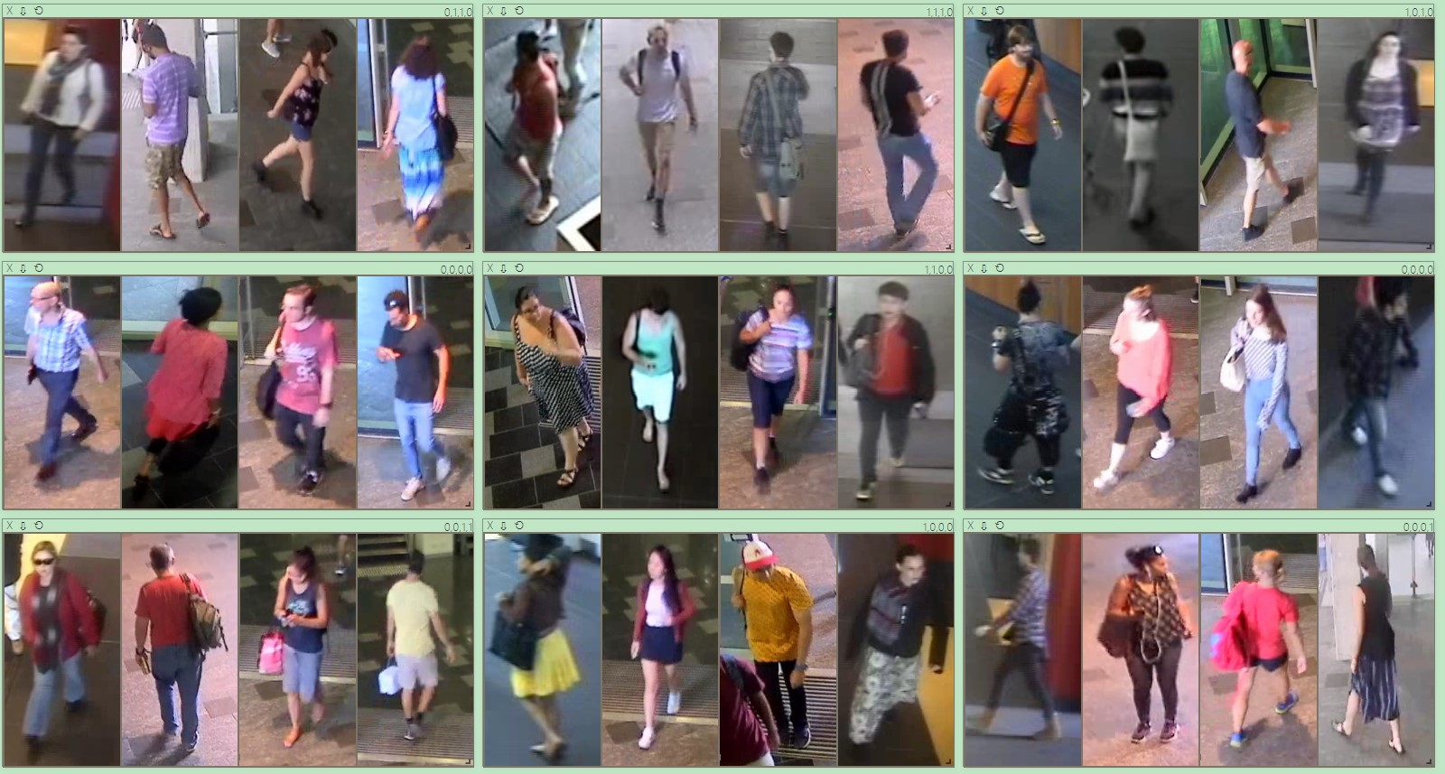

Figure 20: Results of leg clothing type classification.

## Leg Clothing Colour

There are totally 20 Epoch has been used in training. The best train accuracy is 0.998066 and best valid accuracy is 0.664894. Training completed in 5m 36s.

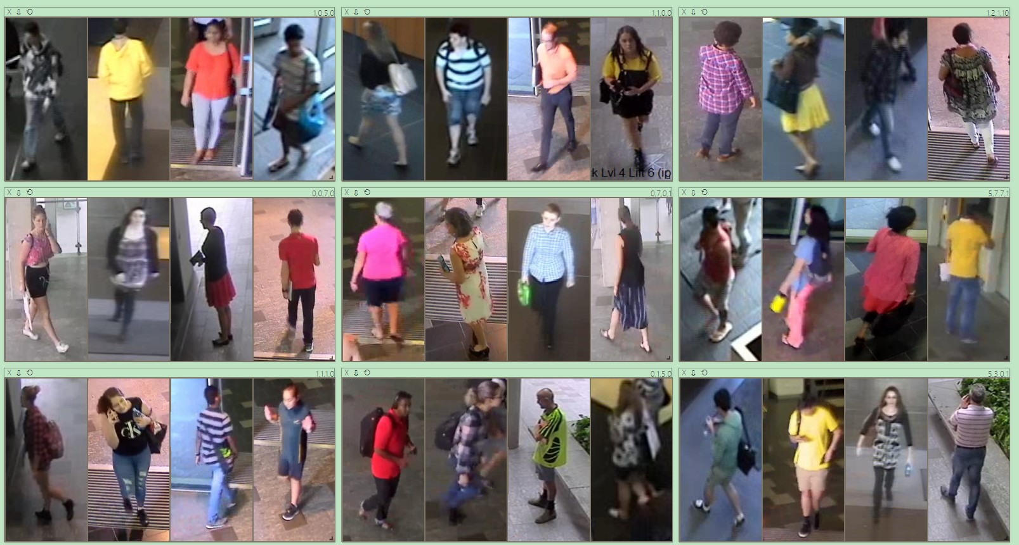

Figure 21: Results of leg clothing colour classification.

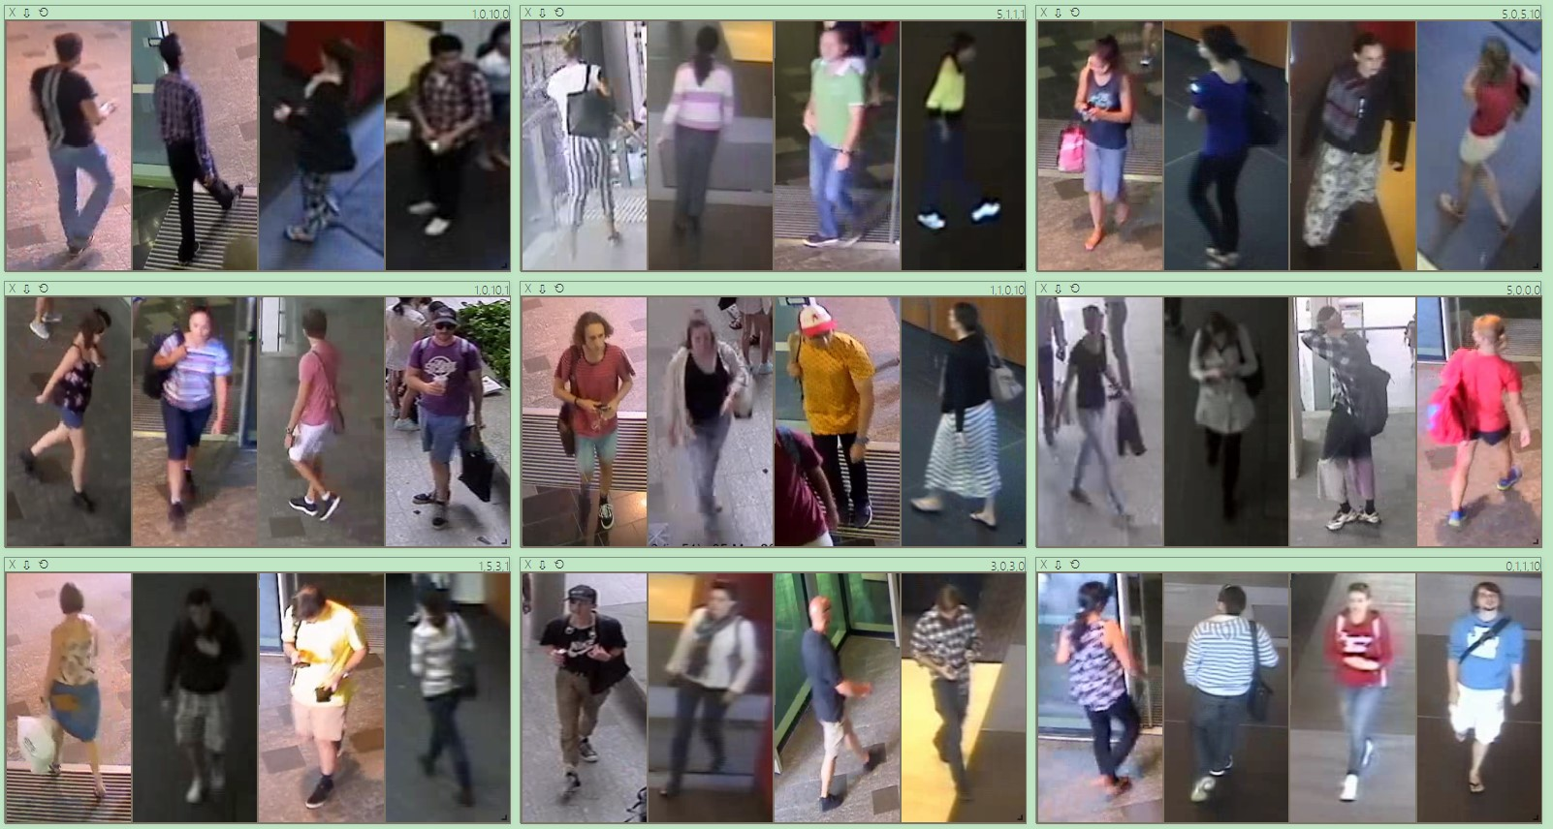

Figure 22: Results of leg clothing colour classification.

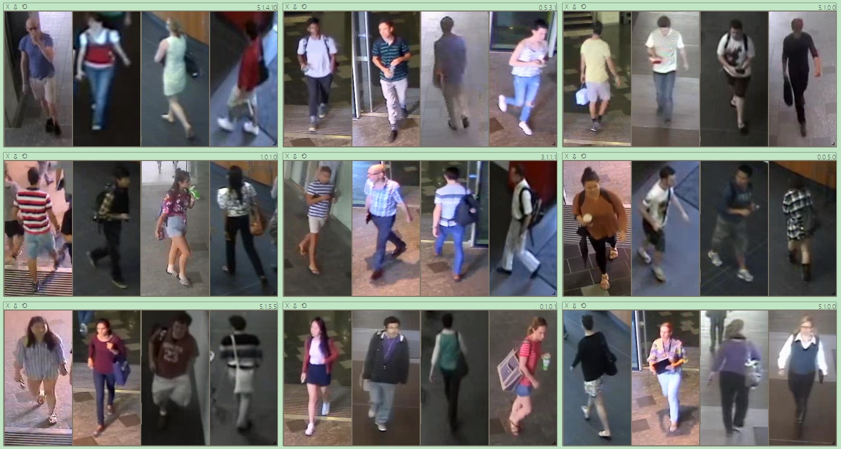

Figure 23: Results of leg clothing colour classification.

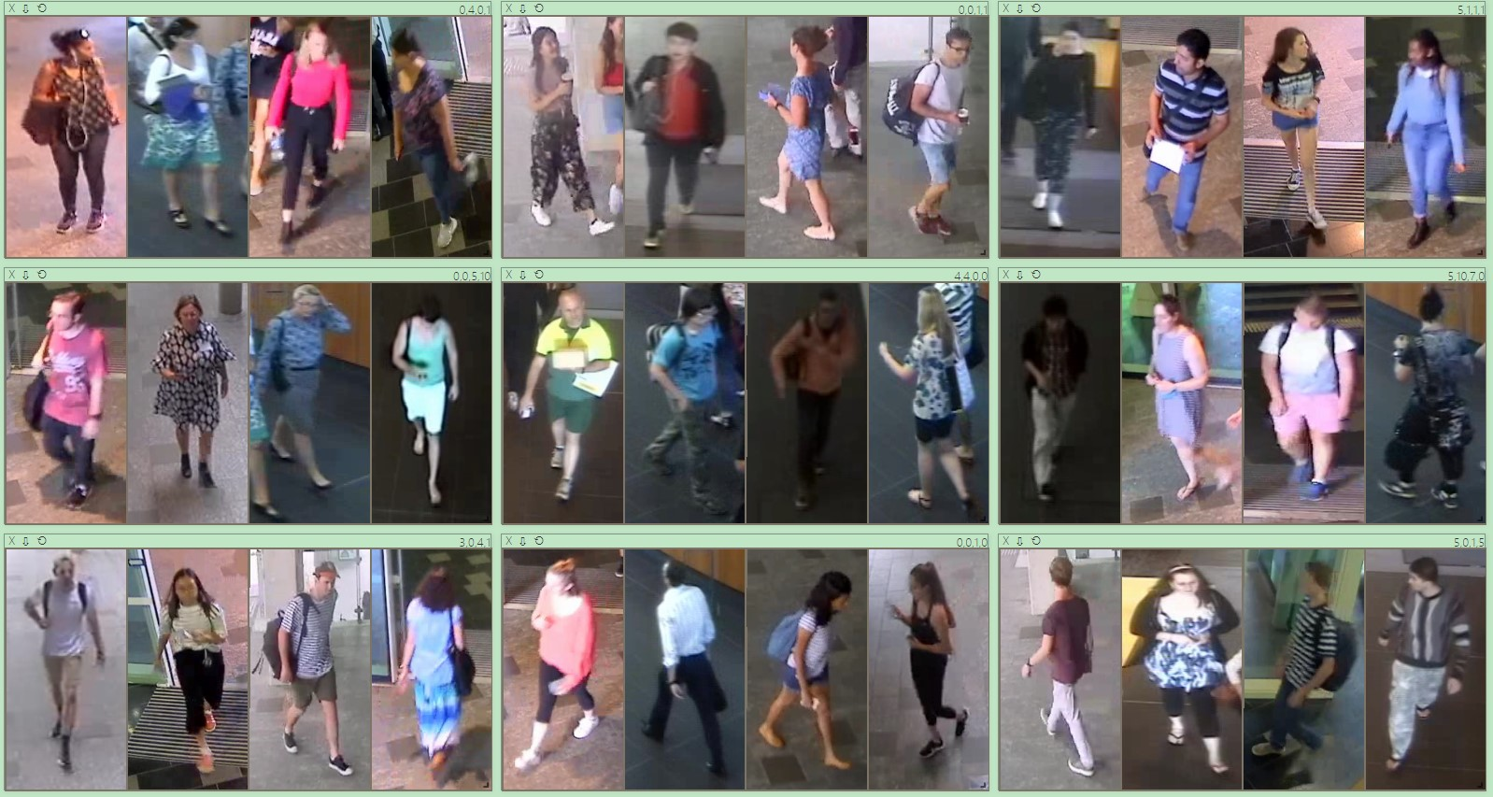

Figure 24: Results of leg clothing colour classification.

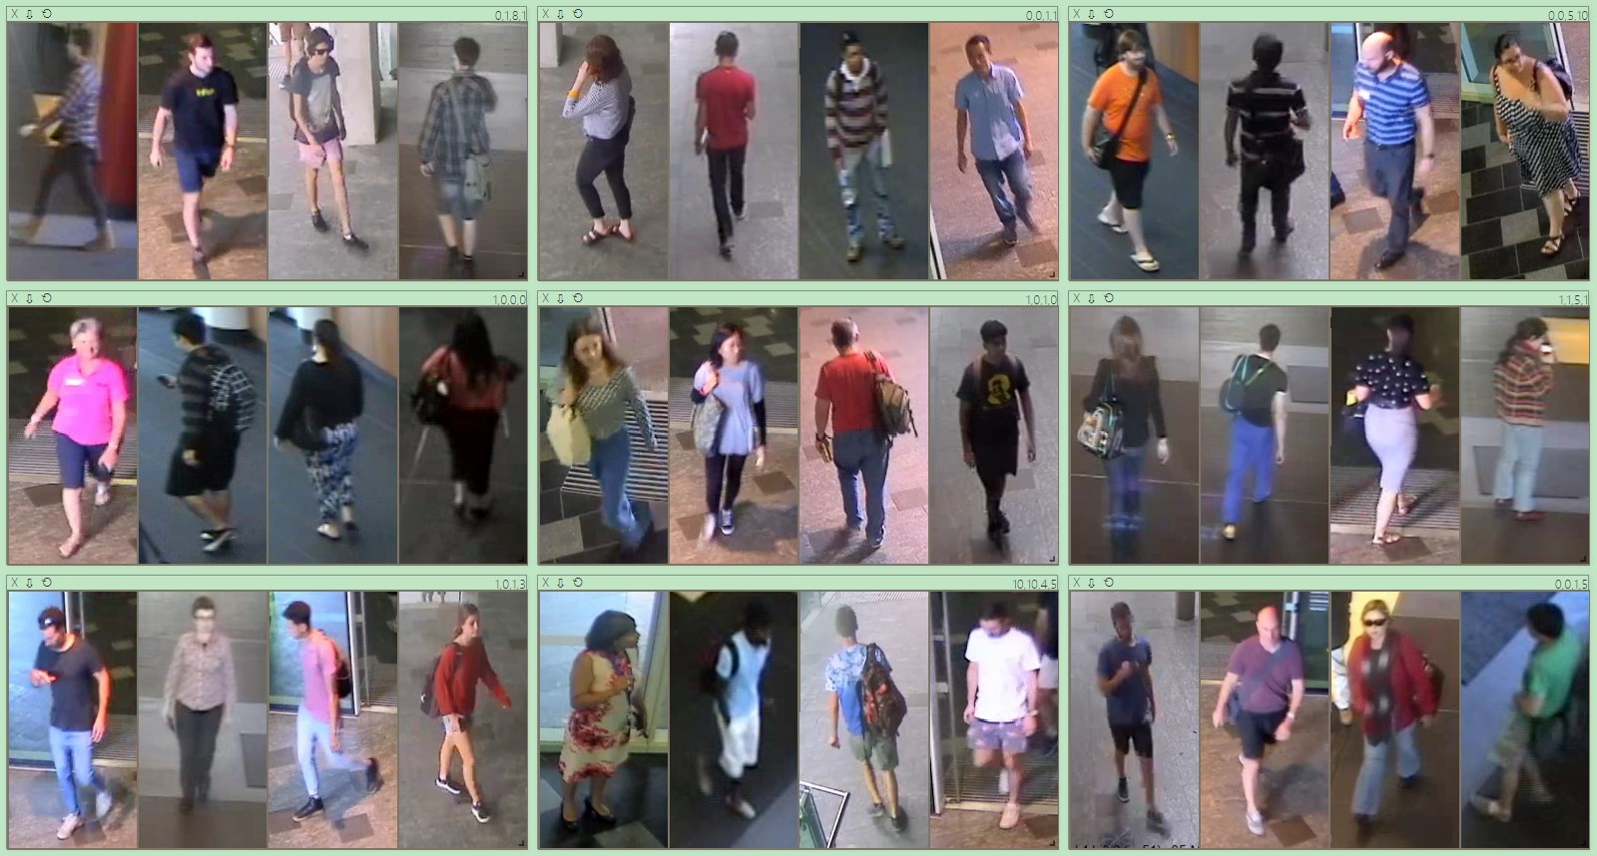

Figure 25: Results of leg clothing colour classification.

## Luggage

There are totally 20 Epoch has been used in training. The best train accuracy is 0.863462 and best valid accuracy is 0.647059. Training was completed in 8m 5s.

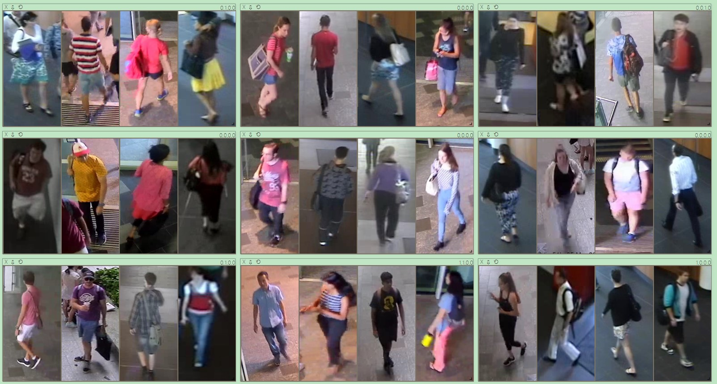

Figure 26: Results of luggage classification.

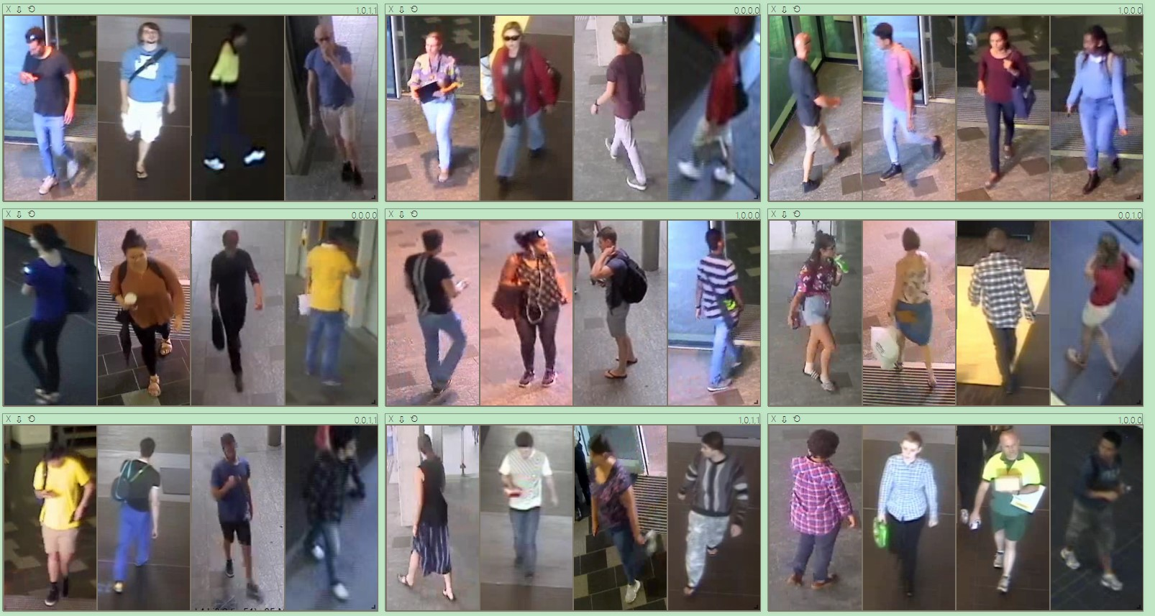

Figure 27: Results of luggage classification.

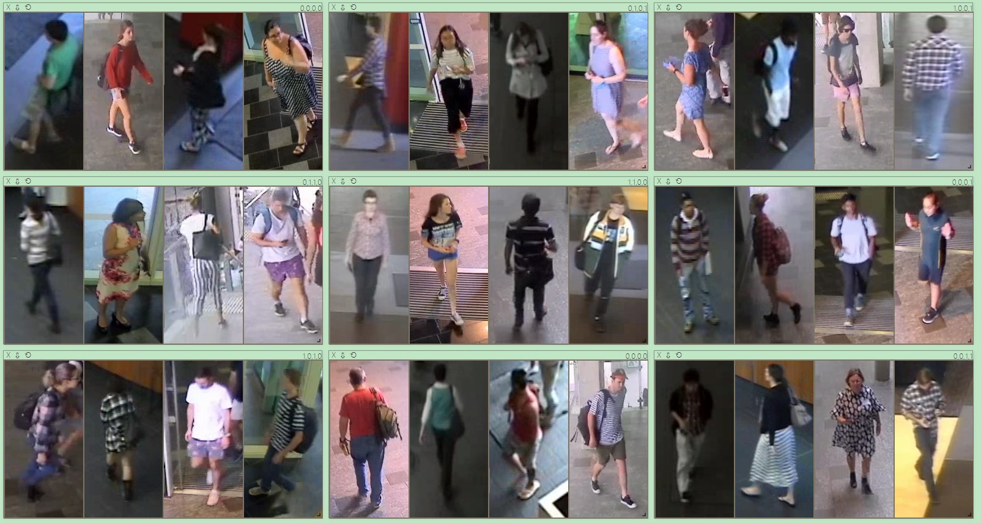

Figure 28: Results of luggage classification.

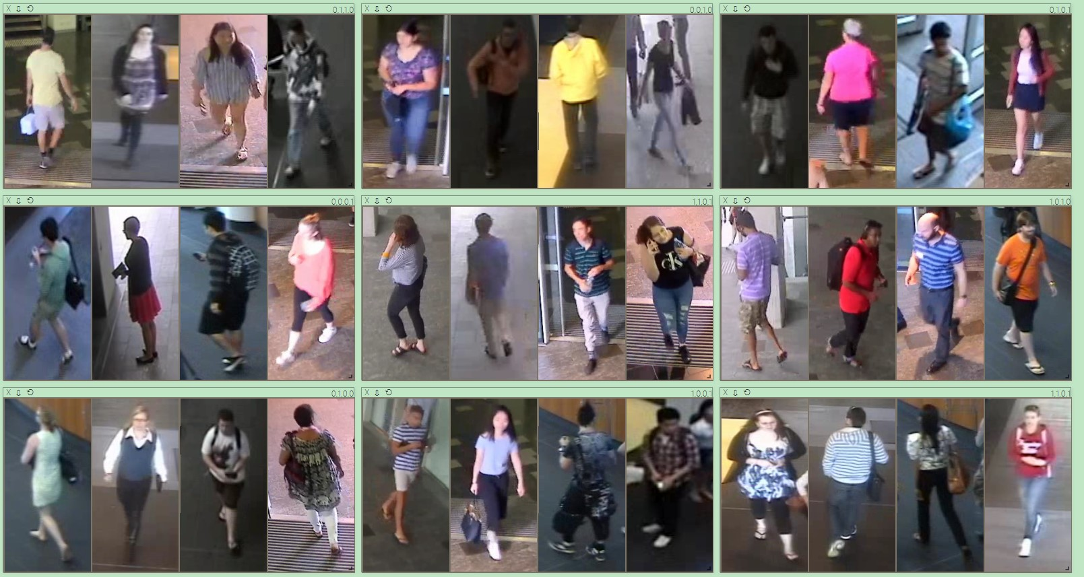

Figure 29: Results of luggage classification.

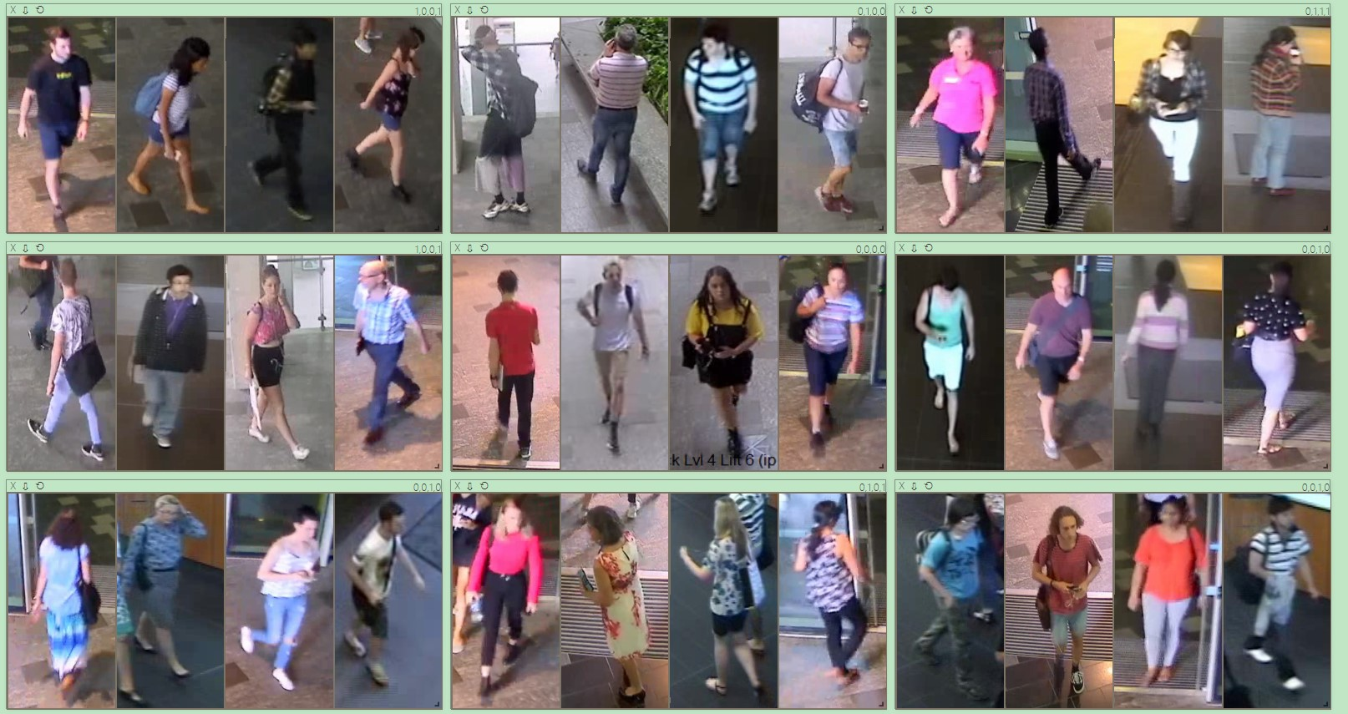

Figure 30: Results of luggage classification.

1. Problems and solution

In this model, training accuracy has achieved significant accuracy which achieved 1.0 accuracy. The majority reason which cause the problem is in some data set there are too many classification but with small amount data, random horizontal flip has been applied to the model for data augmentation. Moreover, the model has overfitting in some points, thus learning rate decay scheduler is using for reduce the overfitting problem. The outcome is significant and achieved satisfied result within small amount of data.